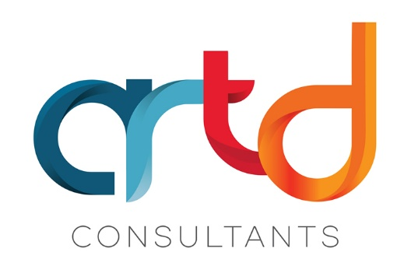

Working with Lived Experience Evaluators in Evaluation
A practical framework

Acknowledgements

We also acknowledge the talent and artistry of Emma Walke, who designed the artwork for our acknowledgment of Aboriginal and Torres Strait Islander peoples. The design shows a story of connection to country and people, representing the breadth of work we do with Aboriginal and Torres Strait Islander communities across Australia. The colours represent the land, and the lines in between represent the water that connects us all.

This Framework has been developed with the input of ARTD Consultants’ Jade Maloney, Sharon Marra-Brown, Alexandra Lorigan, Nama Jalu Consultant Holly Kovak, peer evaluators Kirsty Rosie and Rosie Dale, Rosiel Elwyn, Bliss Jackman, Jen Waltmon
This Framework was presented at the 2023 Suicide Prevention Australia Conference and the 2022 AES Conference.

Introduction
Co-evaluation, like co-design, is informed by the principle of ‘nothing about us, without us.’ While co-design recognises the rights of people with lived experience to shape the policies and programs that affect their lives and the way this strengthens policy, co-evaluation recognises the expertise that people with lived experience bring to designing measures of success, collecting data and making sense of findings and the way this can strengthen evaluation.
ARTD and with some of our lived and living experience evaluators have developed a framework that sets out an approach to engaging with lived and living experience team members. It doesn’t cover every detail. It focuses on the key things to consider from start to finish of a project to ensure meaningful engagement from start to end of a project.
We are continuing to refine this framework through every project, and we will make updates soon.

Readiness
Before you start, you need to make sure your organisation and the individuals involved are ready for the project. Often people think about how ready people with lived and living experience evaluators are. But we find it is first important to understand how ready the organisation is to meaningfully engage with lived and living experience evaluators.
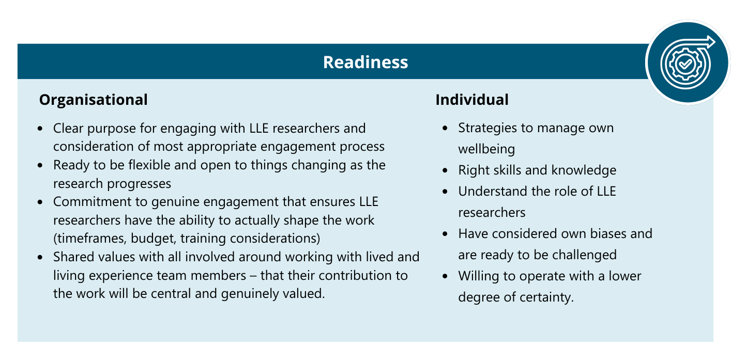

Organisational readiness
It’s essential that, as an organisation, you are ready to work with lived and living experience (LLE) evaluators.
This means:
- having an organisational commitment to genuine engagement that ensures LLE evaluators have the ability to actually shape the work, and there is time and budget to enable this
- having a clear purpose for engaging with LLE evaluators
- considering what the most appropriate engagement process is relative to the type of project
- being clear what has already been set by evaluation commissioners and what is open to designing with lived and living experience evaluators – it is ok if the whole project cannot be co-designed but only if you are clear about that upfront and lived and living experience evaluators are ok to engage on that basis
- being prepared to be flexible and open to things changing as the project progresses
- staff are prepared and supported to engage with LLE evaluators (training requirements have been considered and provided)
- holding conversations with those involved to ensure there are shared values around working with lived and living experience team members and that their contribution to the work will be central and genuinely valued.

Individual readiness
The other part of readiness is the readiness of individuals within the organisation to work with LLE evaluators. Working with people with lived and living experience can affect people in different ways. It might make them anxious that they will do or say the wrong thing. They might feel uncomfortable about the work heading in unexpected directions. The work can be emotionally charged. Individuals working with LLE evaluators need to ensure:
- they have thought about and put in place strategies to manage their own wellbeing
- they have the right skills and knowledge (by engaging in training about trauma for example)
- they understand the role of LLE evaluators and the values of their role
- have considered how their own life experiences, professional training and worldview create bias and are mentally prepared for these biases to be challenged
- they are willing to operate with a lower degree of certainty about project steps, timeframes and directions.

Recruitment
If you don’t already have a network of people with lived and living experience, you need to think about appropriate recruitment strategies.
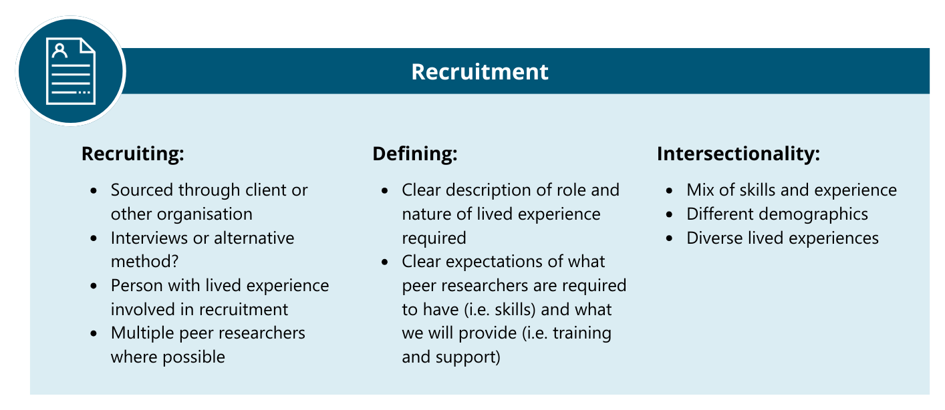
You need to be clear about what skills and experience you are looking for. You also need to make sure your process is accessible and inclusive for reaching those people.
The right people need to be involved in the recruitment process – ideally a person with lived experience – and the tone of care and openness needs to be set right from the outset.
LLE evaluators tell us that clarity and transparency are some of the most important aspects of this stage of the work. It is critical to be very clear about what parts of the project are open to design and change, and which parts are fixed.

Induction and onboarding
Creating a context of psychological safety where people feel genuinely supported and cared for and part of a team is essential to ‘making it work’.
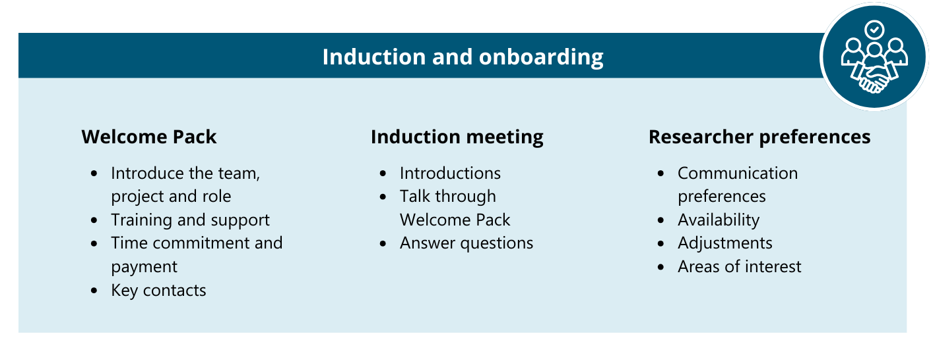
It is important to take the time upfront to get to know each other and work out how you will all best work together.
Sometimes it is important the LLE evaluators come to the project with a particular set of skills in research or evaluation, but more often these can be developed through training and working together. Training should be provided specific to the role the researcher will play in the evaluation, whether that be interviewing or facilitation skills, survey design and analysis or otherwise.
One of the most important things is flexibility, and this starts right from the beginning. It’s important LLE evaluators have choice and control about how they engage on the project and which parts of the project they work on. This, of course, is balanced against the needs of the project and the constraints that the team is working within. Clear communication about this early on ensures that everyone understands and can freely choose whether they want to engage within those constraints or if another opportunity is more suited.
Flexibility applies both to the type of work that LLE evaluators undertake (designing the approach, collecting data, analysing data, etc.) and ways of working. Some people prefer to engage in workshopping things live with others, some prefer to review documents offline and provide feedback, or a mixture of both. All are valid!
Regular meetings should be built into expectations about time commitments, as regular touchpoints and communication are key to:
- getting to know each other and how to work well together (which leads to richer input)
- creating psychological safety
- anticipating and responding to challenges.
Setting up a shared platform for communications can also be helpful – with the caveat that asynchronous chat functions don’t necessarily work for everybody.
There are practical logistics to set up in this phase too, for example: creating and maintaining spreadsheets of LLE evaluators’ contact details, availability, interests and communication preferences; timesheet expectations; and ensuring everyone knows who to approach on the team for what.

Support
A range of supports should be made available to evaluators, including internal support with preparation and tech, and through team check-ins and debriefing; and externally through access to Employee Assistance Programs or other appropriate supports. Consideration should be given as to whether external supervision or mentoring may be additionally required or is desired by evaluators, and to other possible external supports.
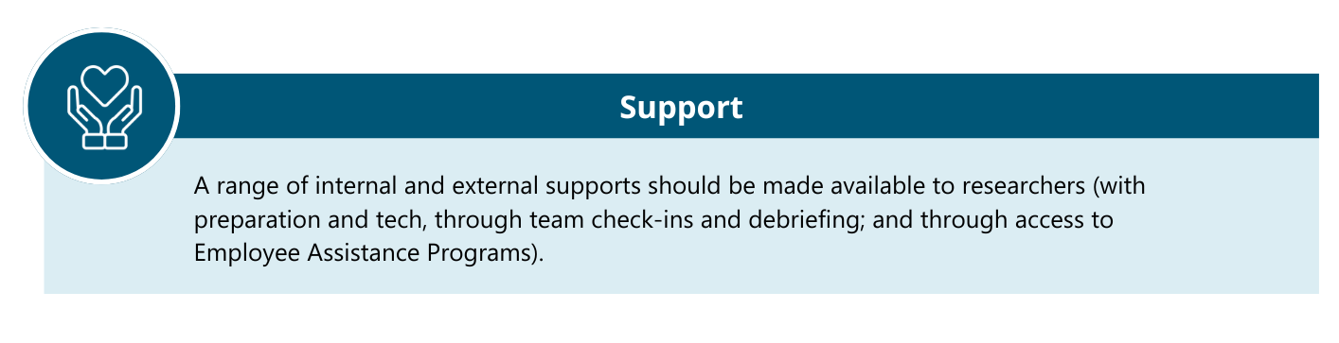
Another, more invisible (but just as essential) internal support that helps make the experience a good one is ensuring that peer evaluators are involved enough that their contribution is meaningful and they genuinely feel like a member of the team, without involving them in the additional cognitive load of all the day-to-day administrative trivia.
It’s always important to remember that LLE evaluators are the experts in their own wellbeing and it’s a balance of providing opportunities for support with respecting their ability to choose what is best for them.

Ways of working
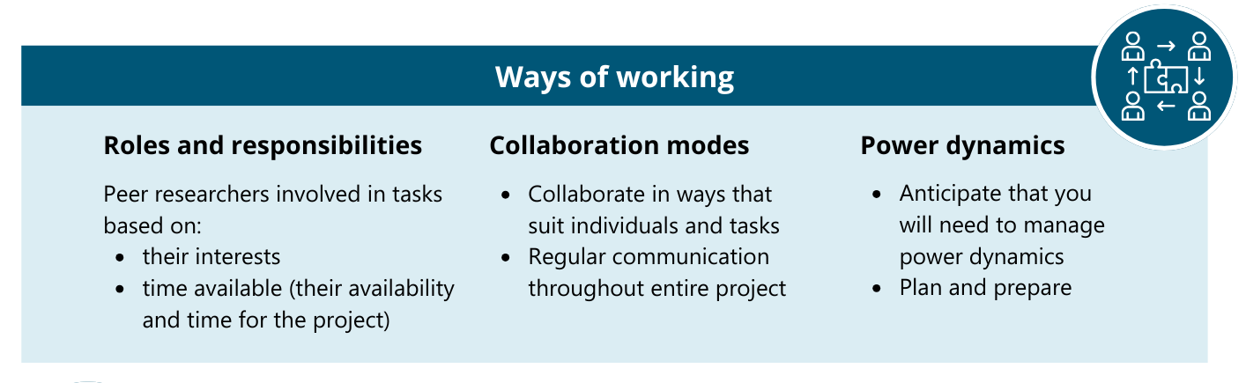
As with so much in evaluation, it’s not only the ‘what’ that is important but the ‘how’. When working together with LLE evaluators, there should be effort made to fit roles and responsibilities to each researcher based on their interests and availability, and to collaborate with them in ways that suit the individual.
Managing power dynamics is also critical to working ethically and safely with lived experience evaluators. Things like money, inherited privilege, being part of a majority group, decision-making authority, and wellness and ability are things that contribute to a position of power (see Lauren Weinstein’s work on Shifting the Powerplay in codesign and her powerplay© cards for more). It is helpful to be aware of three laws of power:
- when power is unequal, it imbalances who has the agency to act
- power accumulates; and
- power can be transformed and transferred.
The power to ask and frame the questions is another kind of power.
Issues with power dynamics can show up in tokenistic involvement (LLE evaluators’ input is not really considered in decision making, for example), or through ‘overt domination, suppressing topics, shaping desires’, by providing unequal compensation etc. Less overt imbalances in power such as the power differential between the evaluation team and lived experience evaluators also needs to be managed through careful attention, and by creating and maintaining a ‘democratic atmosphere to decrease power differentials’.
Conversely, one of the benefits of having people with lived experience on the team is that it can help to address power imbalances between the team and participants of the service or program being evaluated.
From the LLE evaluators’ perspective, the things that make this kind of collaboration work are deep listening, being able to function in a state of uncertainty and not knowing, transparent communication and checking in on assumptions and shared vision.
Rosie Dale worked with ARTD on co-producing and evaluating an aftercare support service for children and young people following significant suicidal ideation, self-harm or a suicide attempt. She has summarised her experience of what makes co-evaluating with lived experience evaluators work, below.

What’s the reality of being a peer researcher?
Rosie Dale – Peer Researcher

Where do you feel you’ve been able to make the most difference?
It is very fulfilling and rewarding to represent someone with lived experience. I also enjoy having opportunities to give input into lots of little things (referral forms, experience measures, survey questions, co-production workshop, program logic, outcomes matrix, evaluation methods) which all add up to something big! Participating in both the evaluation with ARTD and the co-production workshop held by the aftercare service gave me unique insights. It felt empowering to see my name and quotes appearing in the co-production report.
What helps you do this?
Being a part of a back-and-forth conversation really helps, as well as having my feedback taken on board and actually implemented, not just acknowledged. It’s also helpful to be presented with diverse opportunities to give feedback on a variety of things, and to be able to be part in the development of the evaluation project over an extended period of time (rather than giving a one-off contribution). It also really helps to have other peer evaluators in the team, so I have someone to bounce ideas off who thinks on a similar wavelength.

What helped you to feel a part of the team?
A few things:
- consistent, ongoing communication with more or less the same people over an extended period of time (not a one-off interview or seeing different people each time).
- multiple and flexible communication methods (phone call, online meetings, face to face, emails, etc.)
- being paid appropriately
- time taken to get to know people as people, not just workers (e.g., through informal conversations, ice breakers, team meetings). In other words, being treated like a co-worker (which also includes the formal aspects such as timesheets, training, a work email, contracts, payment, etc.)
- being regularly asked for feedback and encouraged to give my opinion on something.
What is challenging about co-evaluating?
I believe that we all have the same goal, but due to different ways of thinking and values, we end up wanting to achieve it in so many different ways! There can be so many different questions, different ways of asking these questions, and different ideas on the best way to ask these questions. Everything from life experience to tertiary studies can inform how we go about asking things and what we think should be prioritised.
What is important to consider in managing power dynamics?
Not being the only peer researcher means feeling less like I'm in a token role, and that my expertise is valued (since one peer researcher can’t encompass all experiences). It's also important to remember that a peer researcher doesn’t have to share aspects of their lived experience they are not comfortable sharing, but at the same time it shouldn’t be awkward if they do share – after all, they are still an employee. It's also beneficial to reflect on the terminology of the role 'peer' researcher – a peer is an equal, with less of the imbalance that often exists in health services. On top of this, it is vital for a peer researcher to be part of a collaborative process with the project and team, not just for. This gives a sense of collective ownership.
What do organisations (evaluators and evaluation commissioners) that want to work with peer evaluators need to consider?
It is important to consider what their motivation is for hiring a peer worker. Is it just because they were told they should, or are they genuinely passionate about the difference it can make?

They need to be clear about what lived experience is, and why the person is applying for the peer researcher role: what does the peer researcher want to gain from their contributions? Organisations also need to consider the specific experience/skills of a peer workers when recruiting, because lived experience can be very broad and diverse.
A peer researcher is just as capable and functioning as other members of the team, they just happen to be open about having lived experience and actively use it to inform their contributions. Other team members may also have LLE but just not use this in their work.
Validation and support comes in many ways! Salary, regular communication, flexibility, language, being inclusive, etc.

Project phases
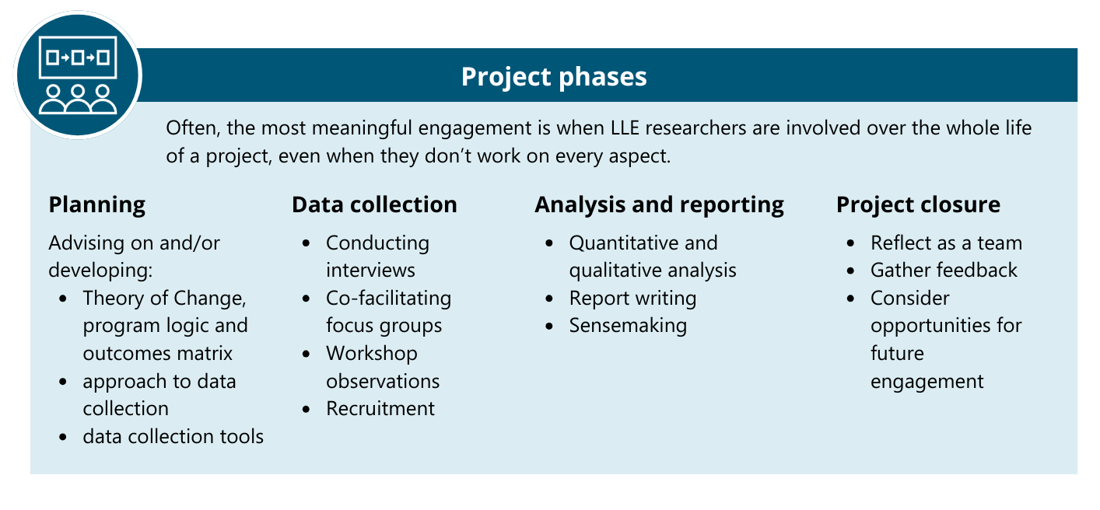
Involving LLE evaluators at each stage of the project (shown above) is ideal, but again this needs to be flexible and recognize that lived and living experience evaluators will want to be involved to different extents, based on their availability and interests. Often, the most meaningful engagement is when LLE evaluators are involved over the whole life of a project, even when they don’t work on every single aspect. Their deep knowledge of the project combined with their lived experience is vital, as is the ease that develops as everyone gets to know each other.

What are the challenges?
There are so many knowledge gains and benefits to working alongside people with lived experience when designing and evaluating projects. But as with any approach, there are also challenges that are helpful to be aware of when planning an evaluation with lived experience evaluators. There’s much in the literature about the challenges faced by the LLE workforce, for example: lack of leadership support; lack of understanding of the purpose, value and bounds of the role, and a lack of appropriate lived experience supervision.
One of the challenges we discussed at our conference session with our panel of LLE evaluators was the difficulty we faced in our project of bringing together people with different lived experiences and views. There was a great deal of complexity in doing so, as different perspectives needed to be worked through, considered and balanced. There are also times when the views of LLE evaluators are different from the views of the commissioner of the evaluation. This can be confronting for everyone and has to be worked through sensitively and genuinely. It is much easier to do so when there is that up front transparency, from the very beginning of the project, about what is fixed and what is able to be changed. While it is challenging to navigate these differences, doing so provides an opportunity for deep reflection and careful consideration and, even when changes aren’t made, this still benefits the project.
Another big challenge is the need to build enough time into the budget and timeline for projects with LLE evaluators, to provide for onboarding, recruiting, training and support. At every point in the project, extra time needs to be built in, to ensure LLE evaluators’ meaningful involvement, and this can create a difficult balancing act for both the client and the evaluator as it requires greater flexibility with how and when things are delivered. Over time, however we have been able to develop a bank of resources for the logistics and training required when working with LLE evaluators. We have also worked with the same evaluators on multiple projects, which has built their skills, saving time on training and onboarding.

What’s the biggest influence working with LLE evaluators has had on us as evaluators?
Working with people with lived experience has had a variety of positive influences on our evaluation practice. One of the key influences of having LLE evaluators on a project is that we are able to take the time to think things through more methodically, as the pace of the project is slower.
Our work with LLE evaluators also prompts us to think about things differently: often, people ask us questions about things that we, as evaluation practitioners, may no longer question. And, our peer evaluators challenge us to think outside the box, be more creative, and produce more accessible consultations and deliverables (and be better at communicating in plain English), which benefits everyone we work with. Through feedback from our LLE evaluators, we find ourselves more aware of the language we use and more frequently considering whether the questions or the way we phrase them may be a risky thing to ask people.
These projects also provide us with the opportunity to learn from observing LLE evaluators with a diversity of experience undertake interviewing.
The ARTD team looks forward to continuing to develop our framework, and insights around working with LLE evaluators.

Want more resources?
We have further blogs on similar topics you can find on our website at www.artd.com.au.

Here is a selection of links to get you started:
- Transparency and Taking the Time – Respectfully Bringing Lived Experience into Program Design and Evaluation
- Toolkit for engaging people with disability in evaluation
- Elevating Lived Experience in Evaluation
- Trauma Informed Interviewing – Tips and Reminders

Connect with us
artd.com.au | (02) 9373 9900


Vojtila, L., Ashfaq, I., Ampofo, A., Dawson, D. and Selby, P. 2021. ‘Engaging a person with lived experience of mental illness in a collaborative care model feasibility study’, Research Involvement and Engagement, 7 (5).
Hertel E, Cheadle A, Matthys J, et al. Engaging patients in primary care design: An evaluation of a novel approach to codesigning care. Health Expect. 2019; 22: 609-616.

