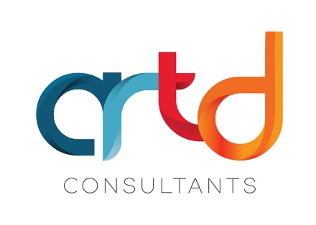

The Independent Evaluation of Australia’s Disability Strategy
ARTD is delighted to announce that we will be leading the Independent Evaluation of Australia’s Disability Strategy.
Australia’s Disability Strategy 2021–2031 (the Strategy) is the national disability policy framework agreed by all levels of government. It recognises the role all governments play in removing barriers and improving outcomes for the one in 5 Australians with disability.
The evaluation will assess:
- how appropriate the Strategy is for the outcomes it should support
- how the Strategy is being implemented
- the difference the Strategy is making for people with disability so far.
ARTD has a 35-year history of working with people with disability. We are committed to the philosophy of ‘nothing about us, without us.’
Working together with people with lived experience, we have built a Lived Experience Evaluation Framework (PDF) or (Word). This framework guides how we share power, working with people to design and deliver and report on accessible, inclusive and impactful evaluations.
For this important evaluation, we have brought together a team of people with disability that we and our partners have worked with in the past to design and deliver evaluations. Our Lived Experience Team will work with us on every stage of the evaluation to ensure accessibility, inclusion and trust in the process.
Our partners for this project are Taylor Fry, Social Research Centre, Keogh Bay, Ethnolink, Australian Federation of Disability Organisations (AFDO) and AMAZE.
A Steering Committee of people with disability will oversee the evaluation. Australia’s Disability Strategy Advisory Council will also inform the evaluation process.
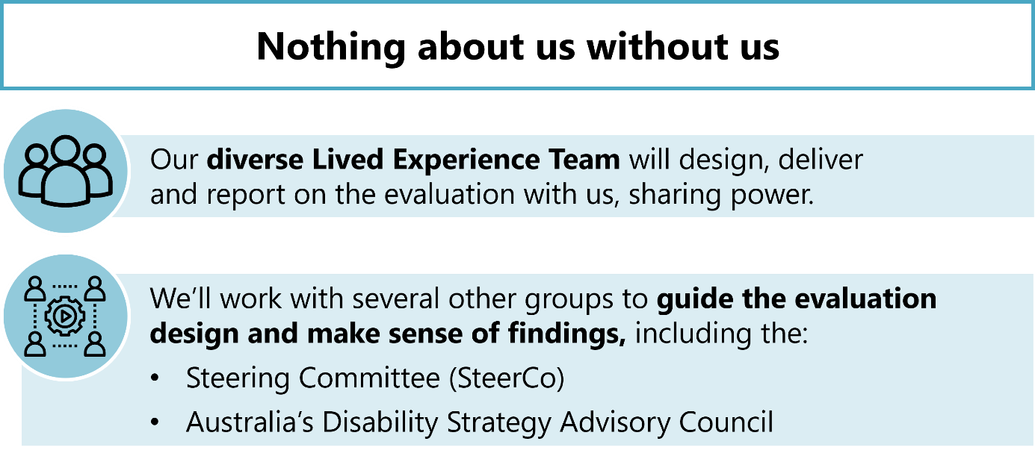
Working with specialist partners, we will make sure we:
- make the best use of available data
- connect with community
- engage First Nations and culturally and linguistically diverse communities
- deliver a robust national survey.
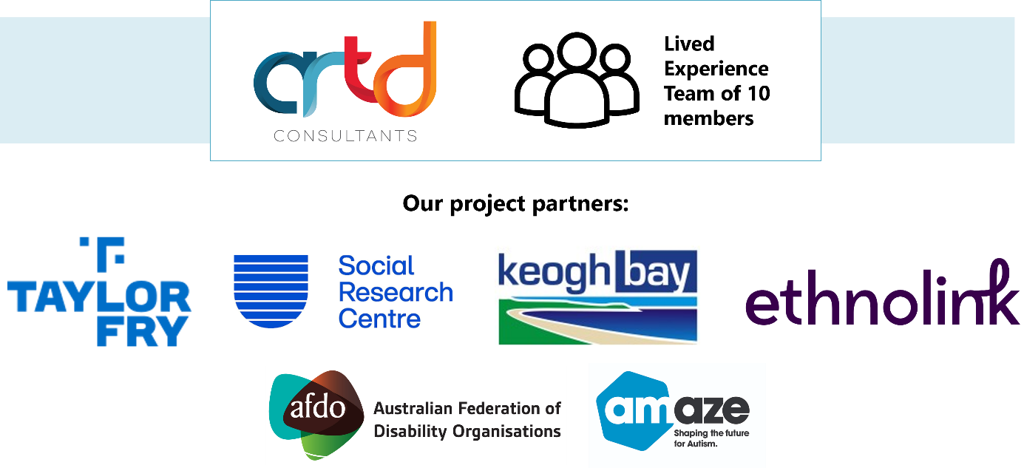
You can register your interest to be involved in data collection here. Please note, we are currently designing the evaluation and can only gather and use this information in our report to government once we have ethics approval.
If you would like further information about the evaluation, reach out to our team at ADSevaluation@artd.com.au.
We are grateful for the opportunity to deliver this evaluation and are looking forward to hearing from you.

